King Fahd University of Petroleum and Minerals
Information and Computer Science Department

ICS 103: Computer Programming in C
Fall Semester 2007-2008 (Term-071)

Major Exam-I

Time:100 minutes Saturday, October 27, 2007

Name:
ID#:

PLEASE CIRCLE YOUR SECTION BELOW:

Section | 01 | 02 | 03 | 04 | 05 | 06
Time | UT-9-10 | UT 8-9 | UT 10-11 | UT 11-12 | UT 1:2 | SM 9-10

Note:

- Copying or Discussion will result in zero grade for all the students involved.
- Attempt all questions.

Question # | Maximum Marks | Obtained Marks
1 | 12x1.5=18
2 | 6
3 | 6
4 | 8
5 | 10
6 | 10
7 | 10
8 | 12
9 | 20
Total | 100

Question 1: (18 points-1.5 each expression)

Find the values of the following expressions.

expression | Value

7/2*2.0

5%7

5+3/2.0

11-3/2

13-5/2.0

5<3<=2-5

5!=4!=1

5>2>0

(double)(5/2)

(int)(7/2.0)

5!=1<0

10/4/2.0

Question 2 (6 points )
Find the equivalent expression by removing the brackets

expression | Equivalent expression without brackets

!(6<=x && x < 50)

!((a && b) || (c && d))

!(a==b && c!= d)

Question 3 (6 points )
What will be the values of x, y, and z after executing the following statements.
int x=5.623;
double y=x;
double z=5/2;

x y z

Question 4 (8 points )

Given the following program. Write 2 printf statements to have the output shown below the program. Each square represents one space.

#include <stdio.h>
int main(void) {
int i=504;
double x=302.568, z=-12.31;

_____________________________________

_______________________________________

return 0;
}

 | 3 | 0 | 2 | . | 5 | 7 |  | - | 1 | 2 |  | 5 | 0 | 4
 | - | 1 | 2 | . | 3 | 1 | 0 |  |  | 3 | 0 | 2 | . | 6 |  |  | 5 | 0 | 4

Question 5 (10 points )
Write the corresponding mathematical or C expression

C EXPRESSION | Mathematical Expression
 | $$\frac{x^{2}−3x}{\sqrt[3]{x^{2}}}$$
exp(abs(x)+y)/x+y

 | $$(4+\frac{1}{x})(6x−\frac{1}{x^{y}+2}$$
8+sin(x)/y-exp(y)

Question 6: 10 points
Consider the following program
#include <stdio.h>
int main() {
double x;
printf("enter a value for x >");
scanf("%lf",&x);
if(x > 60)
printf("East");
else if (x > 80 )
printf("North");
else if(x > 50)
printf("West");
else if( x > 70)
printf("South");
else
printf("Nowhere");
return 0;
}
The above program compiles and runs without errors. Indicate the exact range of the values of x (entered by the user) for each of the words printed by the program. One choice can be selected more than one time.

- This word cannot be printed
- x > 60
Word printed  By the program | Exact range of x values typed by the user. Select 1 choice
East
North
West
South
Nowhere
- x > 80
- x > 50
- x > 70
- 50 <x ≤ 60
- 50 < x ≤ 80
- 60 < x ≤ 80
- x ≤ 50
- x ≤ 60

Question 7 (10 points)
What is the output of the following program
#include <stdio.h>
int main() {
int x;
Value of x typed  By user | Program output
1
2
3
5
6
printf(“Enter a value for x >”);
scanf(“%d”, &x);
switch(x) {
case 1: x=x+1;
case 3: x=x+2;
case 5: if(x==4)
x=x+6;
break;
case 6: x=x+3;
default : x=x-1;
}
printf("%d\n",x);
return 0;}

Question 8 (12 points)
Write a c program that asks the user to enter a weekday initial (Use initials used in your class schedule i.e. S,U,M,T, and W). The user may type the day initial as lower case or capital. Then your program will print the corresponding day name. Use switch statement and use default for invalid input.
Samples of executing your program.

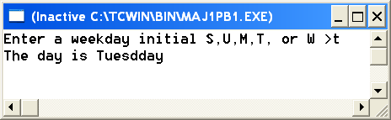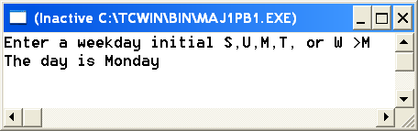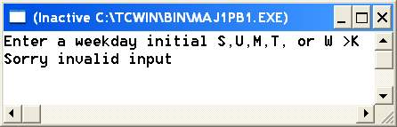

Question 9 (20 points)
The Body Mass Index (BMI) formula is an internationally used measure of obesity. Calculating body mass index requires only two measurements, height and weight. Your program should allow the user to enter the weight and height either in (pound, inch) or (kilogram, meter). The formula for computing BMI is as follows:

$\text{BMI}({\text{kg}}/{m^{2}})=\frac{\text{weight}×\text{703}}{{\text{height}}^{2}}$in case weight in pounds and height in inches
$\text{BMI}({\text{kg}}/{m^{2}})=\frac{\text{weight}}{{\text{height}}^{2}}$ in case weight in kilograms and height in meters
BMI | Weight Status
Below 18.5 | Underweight
18.5 -24.99 | Normal
25 - 29.99 | Overweight
30 and Above | Obese
Your program should print one of the weight statuses indicated on the second column of the table above based on the value of BMI found.
Here are some executions of the program
